Quadratic Links 2

Matching

The following ‘cards’ are in no particular order
Use the cards, either by cutting them out or by labeling, to create 6 groups. Each graph card has 4 corresponding text cards that go with it!

In this case, however, the graph cards are blank! Your task is to group the text cards and then make a mathematical ‘sketch’ of the graph on one of the blank cards!

As before, an example of what a finished group might look like is shown below

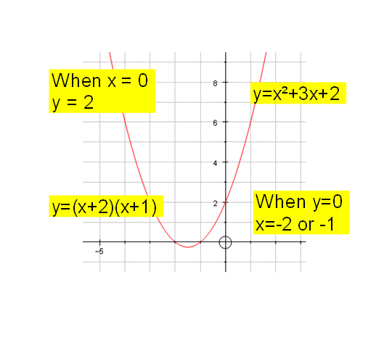

y= x² - 5x + 6 | y= (x + 3)(x + 4) | When x = 0,  y = 12 | When y = 0,  x = -2
y= x² - 4 | y= (x + 2)² | When x = 0,  y = -4 | When y = 0,  x = 2 and - 2
y= x² + 3x + 2 | y= (x + 2)(x – 2) | When x = 0,  y = 2 | When y = 0,  x = 3 and 2
y=x² + 2x + 4 | y = (x – 3)(x – 2) | When x = 0,  y = 4 | When y = 0,  x = -3 and -4
y=x² + 7x + 12 | y= (-x + 3)(x - 2) | When x = 0,  y = 6 | When y = 0,  x = -2 and -1
y= -x² +5x - 6 | y= (x + 2)(x + 1) | When x = 0,  y = -6 | When y = 0,  x = 3 and 2

